**Assignment 3.5**

1. Import the Titanic Dataset from the link Titanic Data Set.

Perform the following:

a. Is there any difference in fares by different class of tickets?

Note - Show a boxplot displaying the distribution of fares by class

library(titanic)

library(ggplot2)

Titanic_Train_names$Pclass=as.factor(Titanic_Train_names$Pclass)

fill <- "#4271AE"

line <- "#1F3552"

boxplot_tit_fare_class=

ggplot(data = Titanic_Train_names,aes(Titanic_Train_names$Pclass,Titanic_Train_names$Fare))+ geom_boxplot(fill=fill, colour=line)+ scale_y_continuous(breaks = seq(0,200,10), limits=c(0,200), name = "Fare range based on class") + scale_x_discrete(name = "Class of Tickets") + ggtitle("Fare charged on the basis of ticket class")

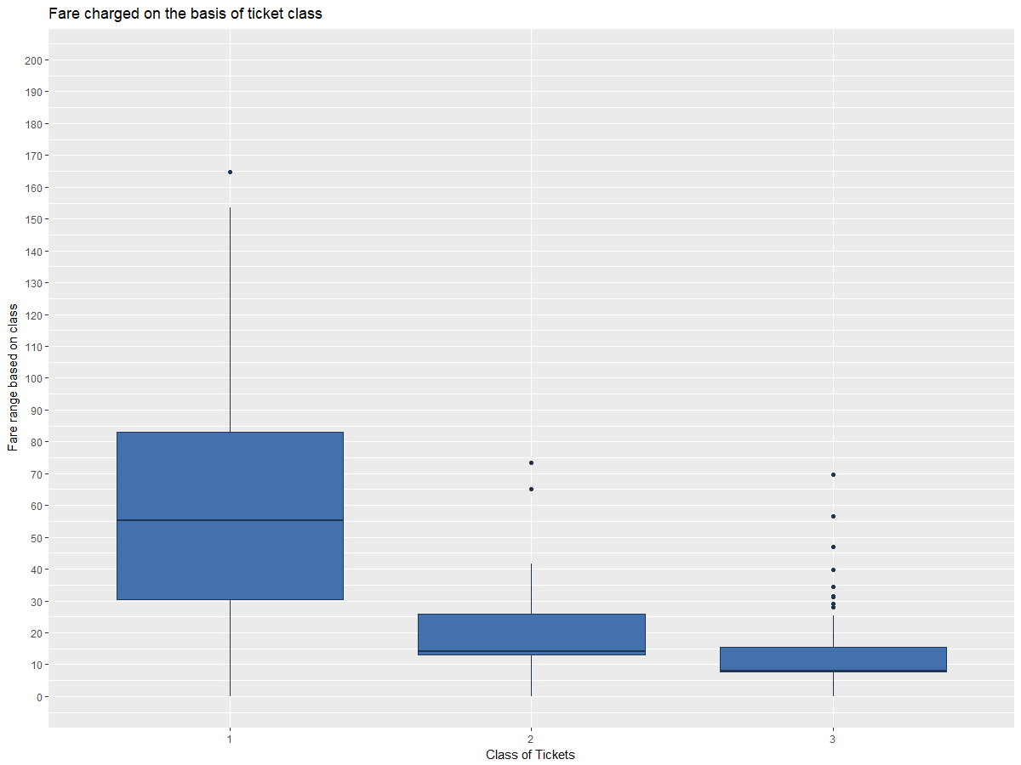

b. Is there any association with Passenger class and gender?

Note – Show a stacked bar chart

count= table(titanic_train$Sex,titanic_train$Pclass)

cols = c("hotpink4" , "royalblue")

barplot(count, col = cols, legend.text = TRUE,beside = FALSE, main = "Gender vs Class", xlab = "Pclass", ylab="gender",  args.legend = list(x = "topright"))

